|  |  | HUMCOM 1  Human Computer Interaction |
| --- | --- | --- |

BSCS 1, IAA 1

student NAME

This portfolio showcases my activities, experiential learnings, and reflections in (HUMCOM 1) this semester under the supervision of our instructor Mr. Benny Cris C. Pio.



## End semester self-assessment

Throughout the HUMCOM 1 subject, I gained valuable foundational skills in web development and digital communication. We learned how to use HTML, CSS, and JavaScript to build and structure websites, which gave me a clearer understanding of how websites work behind the scenes. I especially enjoyed applying these skills through hands-on activities like designing web layouts using Canva. This subject not only enhanced my technical skills but also allowed me to be creative in presenting content visually. Overall, HUMCOM 1 helped me appreciate the importance of combining functionality and design in creating effective digital communication platforms.

**Table of Contents**

**End semester self-assessment 1**

***Quiz 1: 3***

**Quiz 2: 4**

**Quiz 3: 5**

**Quiz 4: 6**

**Quiz 5: 7**

**Quiz 6: 8**

**Quiz 7: 9**

**Quiz 8: 10**

**Quiz 9: 11**

**Quiz 10: 12**

**Quiz 11: 13**

**Seatworks 14**

**Assignments 15**

***Experience 16***

**What I like about the course: 16**

**My Favorite Topics 16**

**My Favorite Activities 16**

**What can be improved in this subject 16**

**Most Challenging Topics 16**

# Quiz 1:

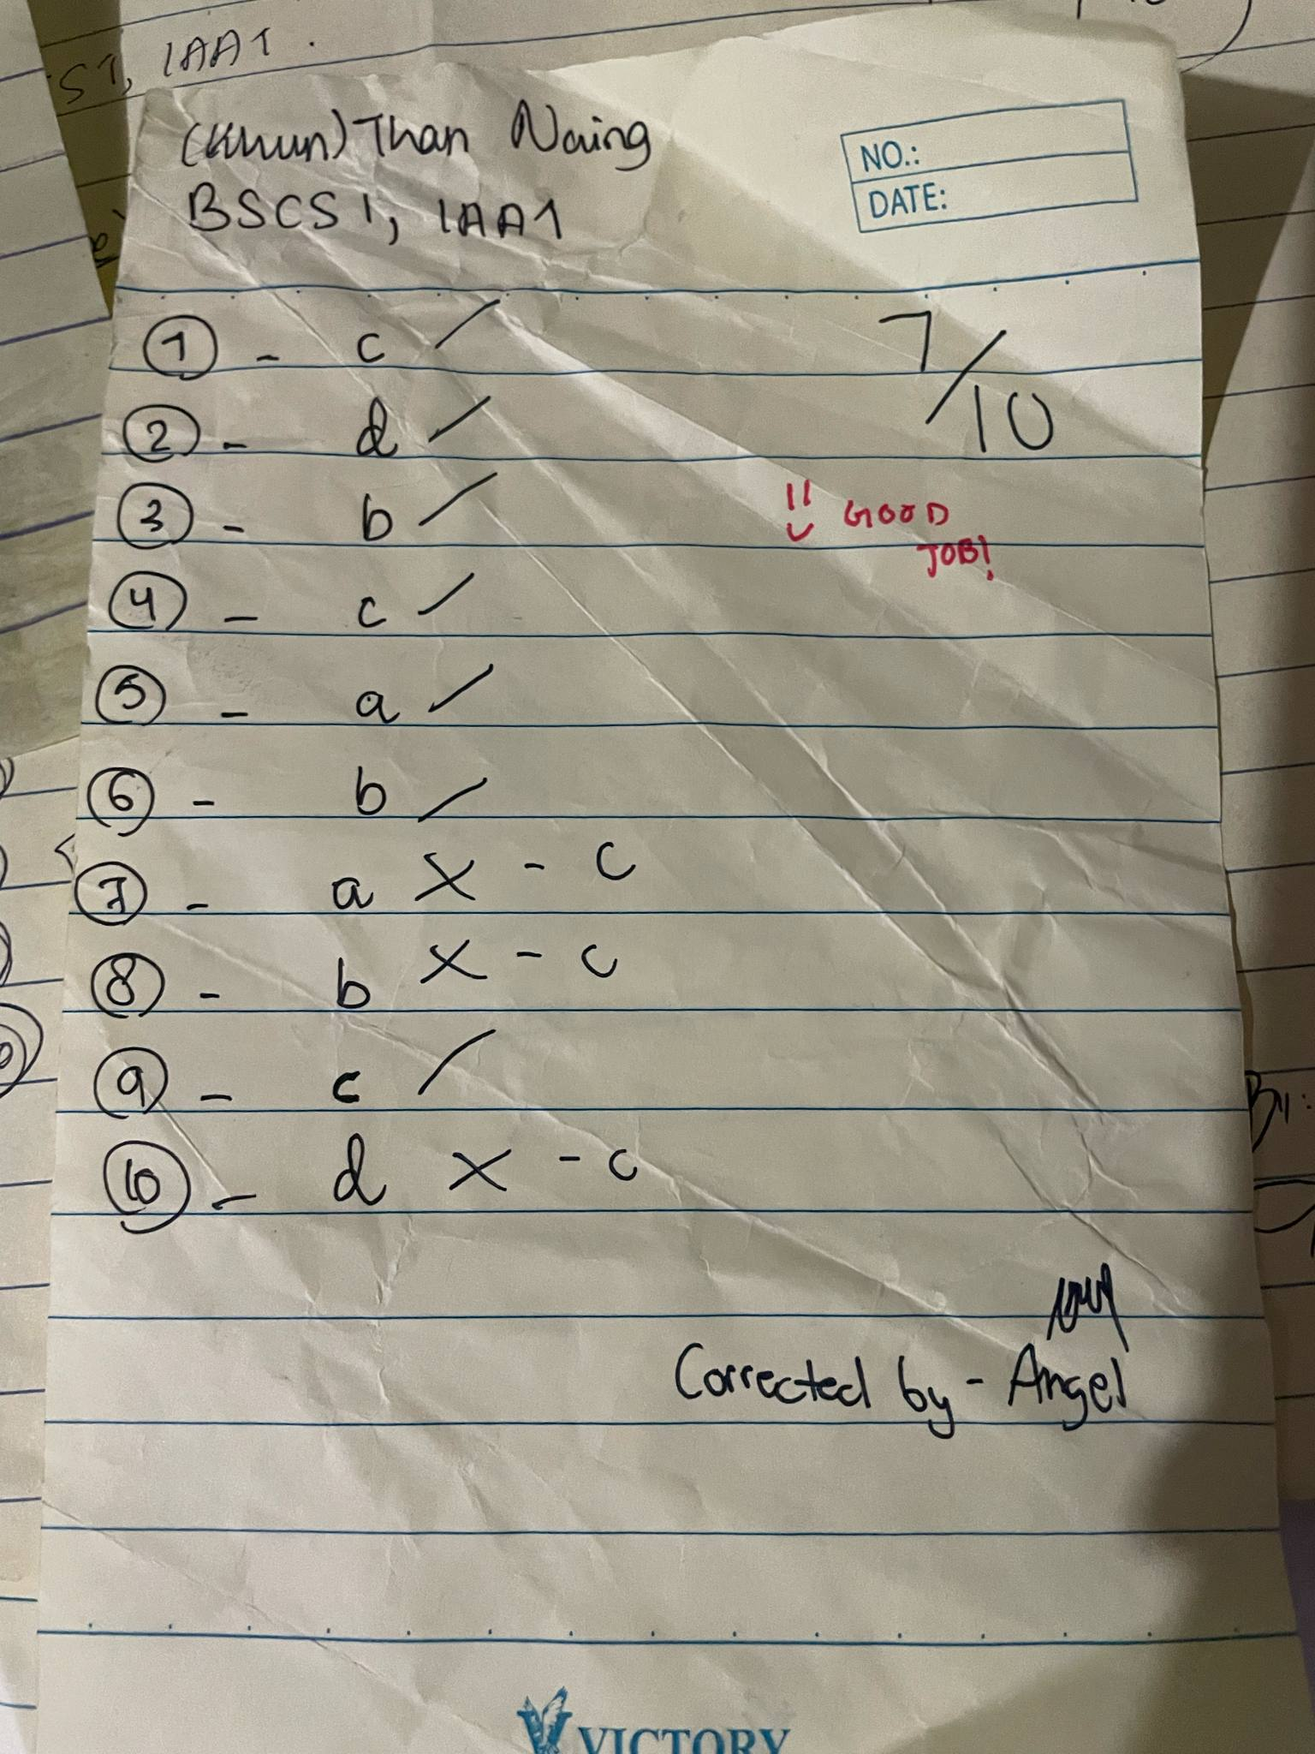

# Quiz 2:

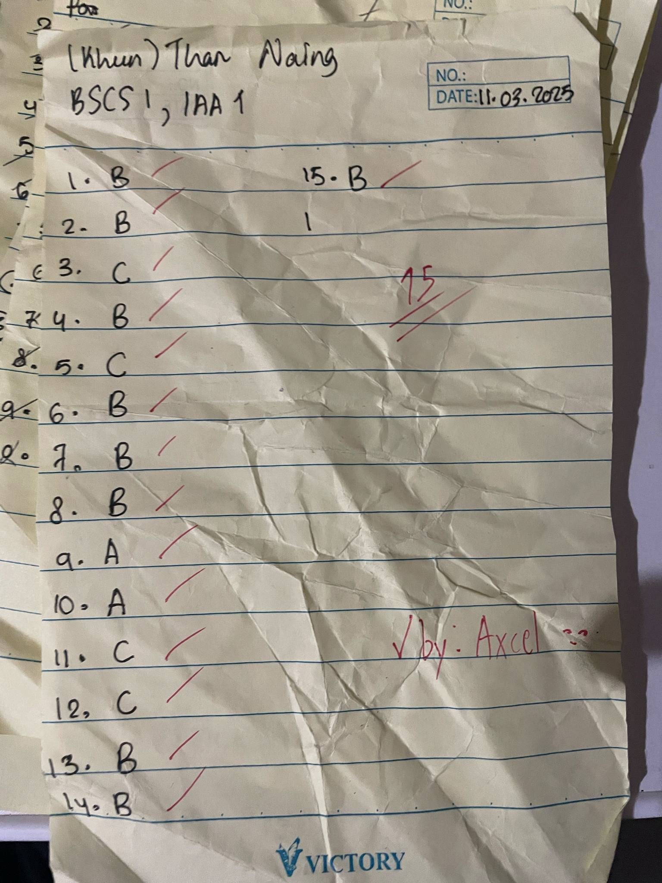

# Quiz 3:

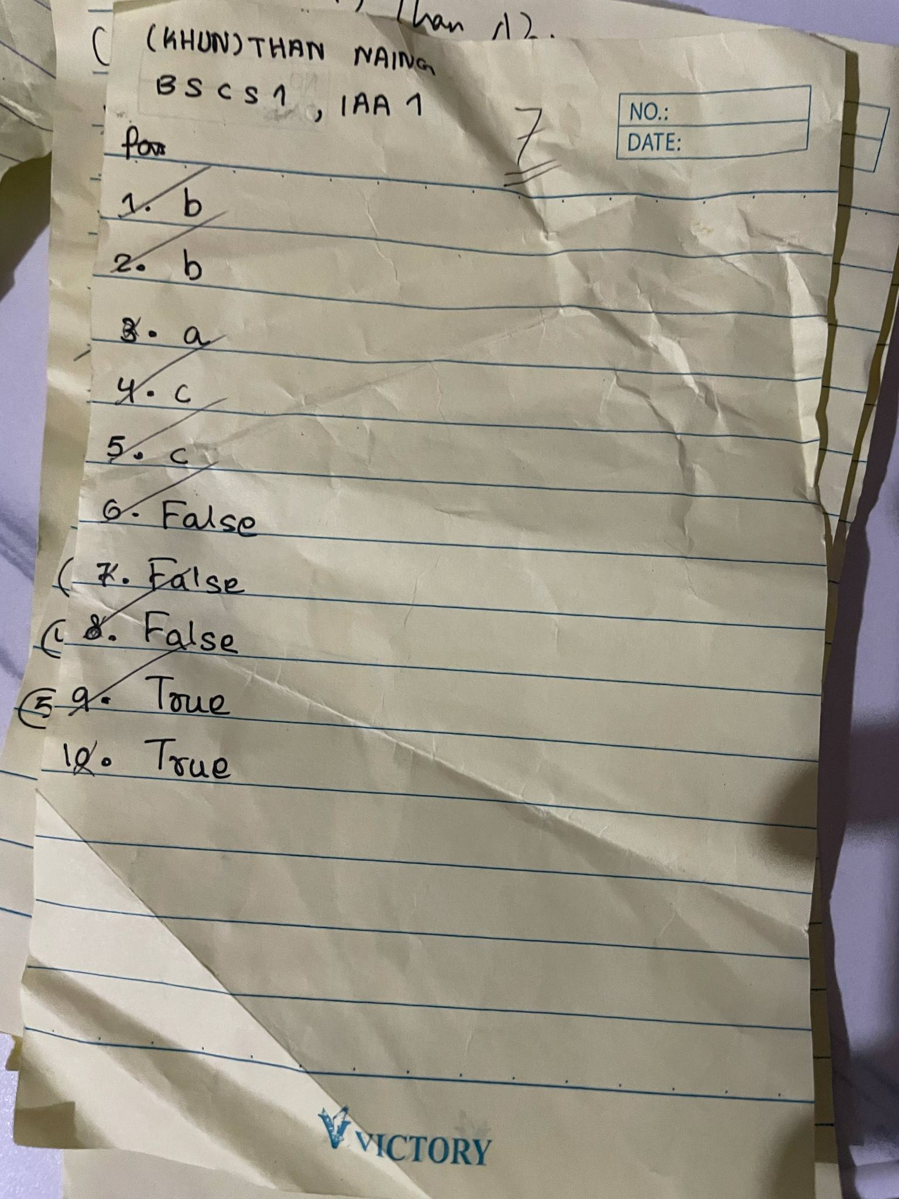

# Quiz 4:

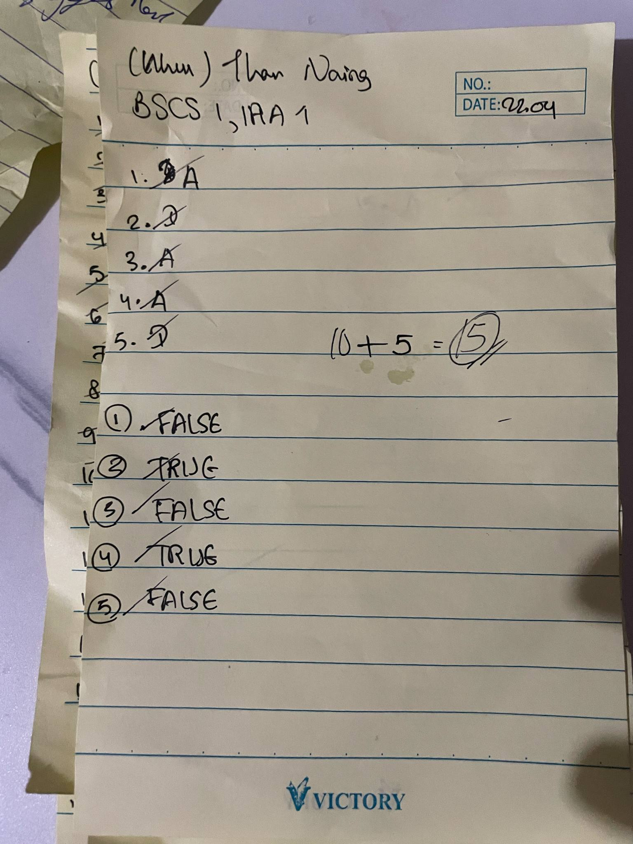

# Quiz 5:

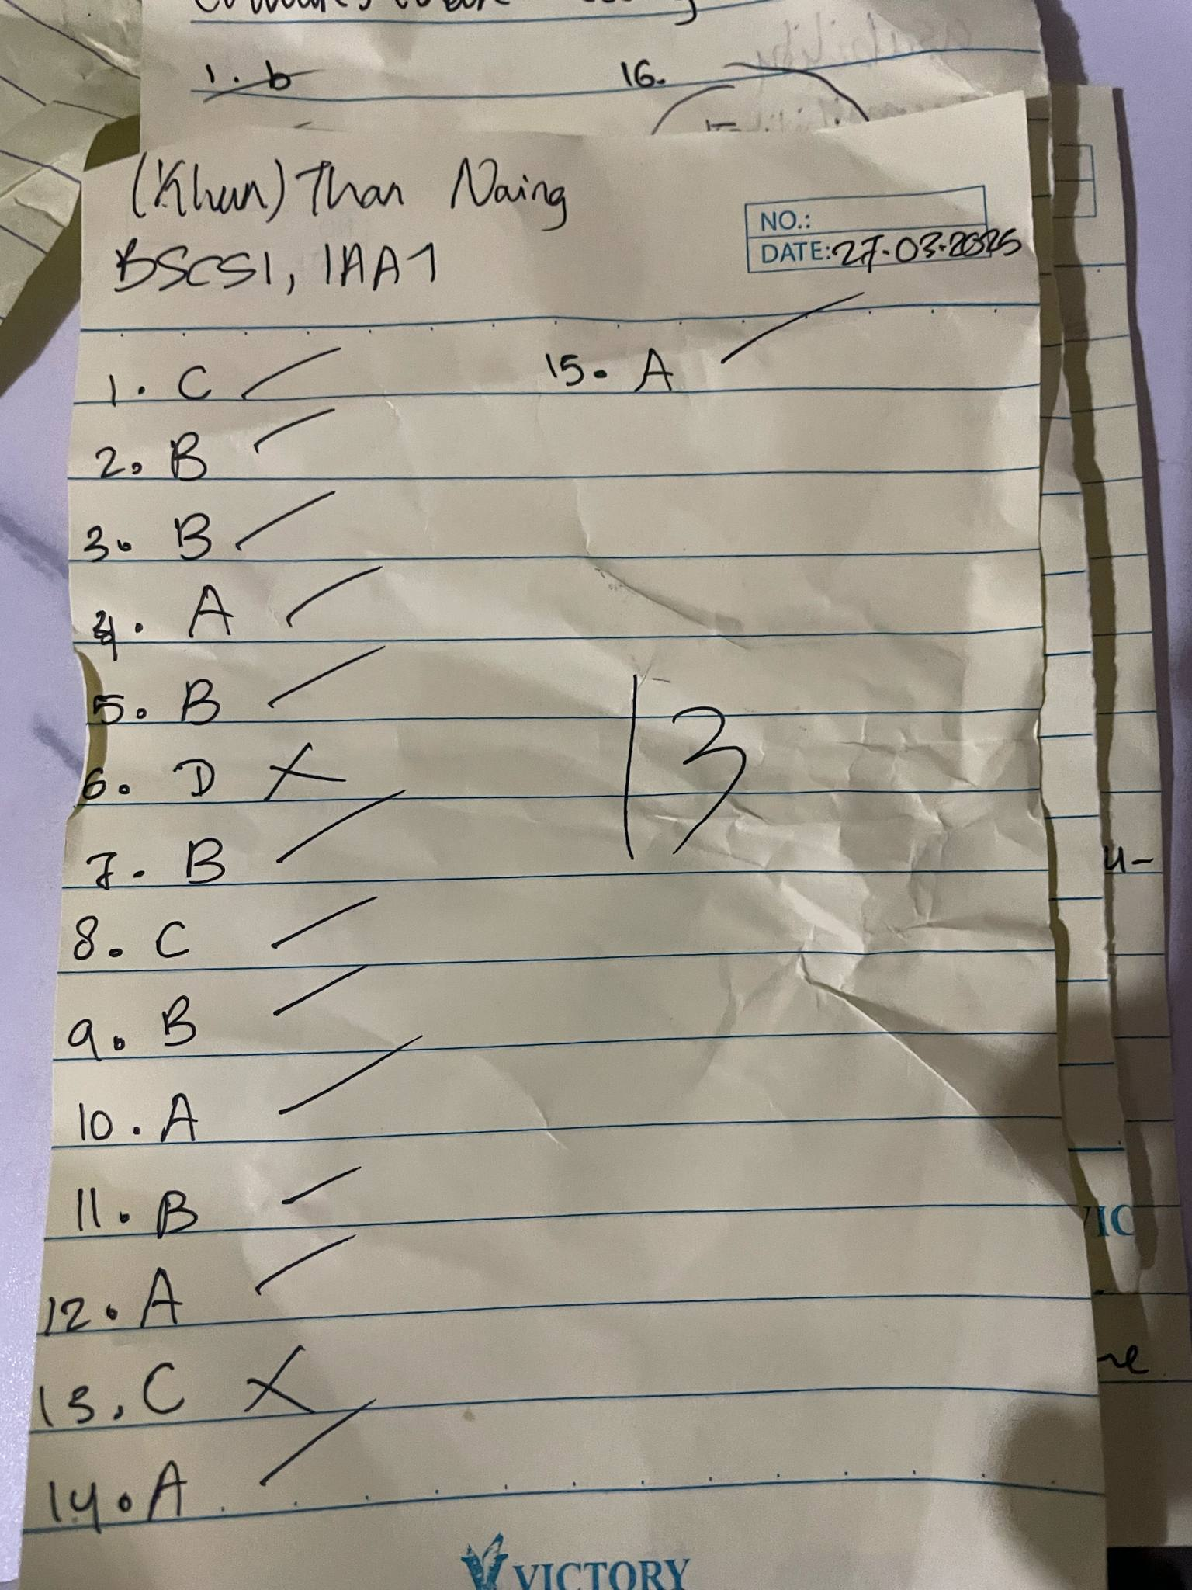

# Quiz 6:

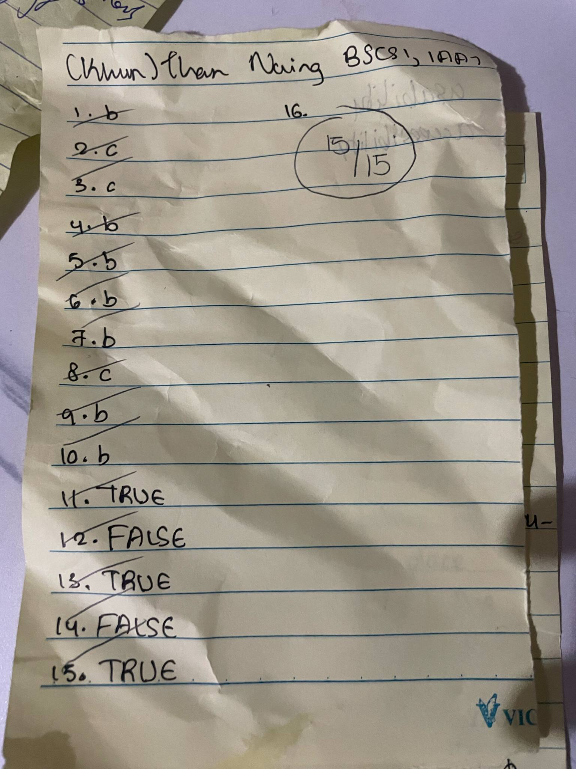

# Quiz 7:

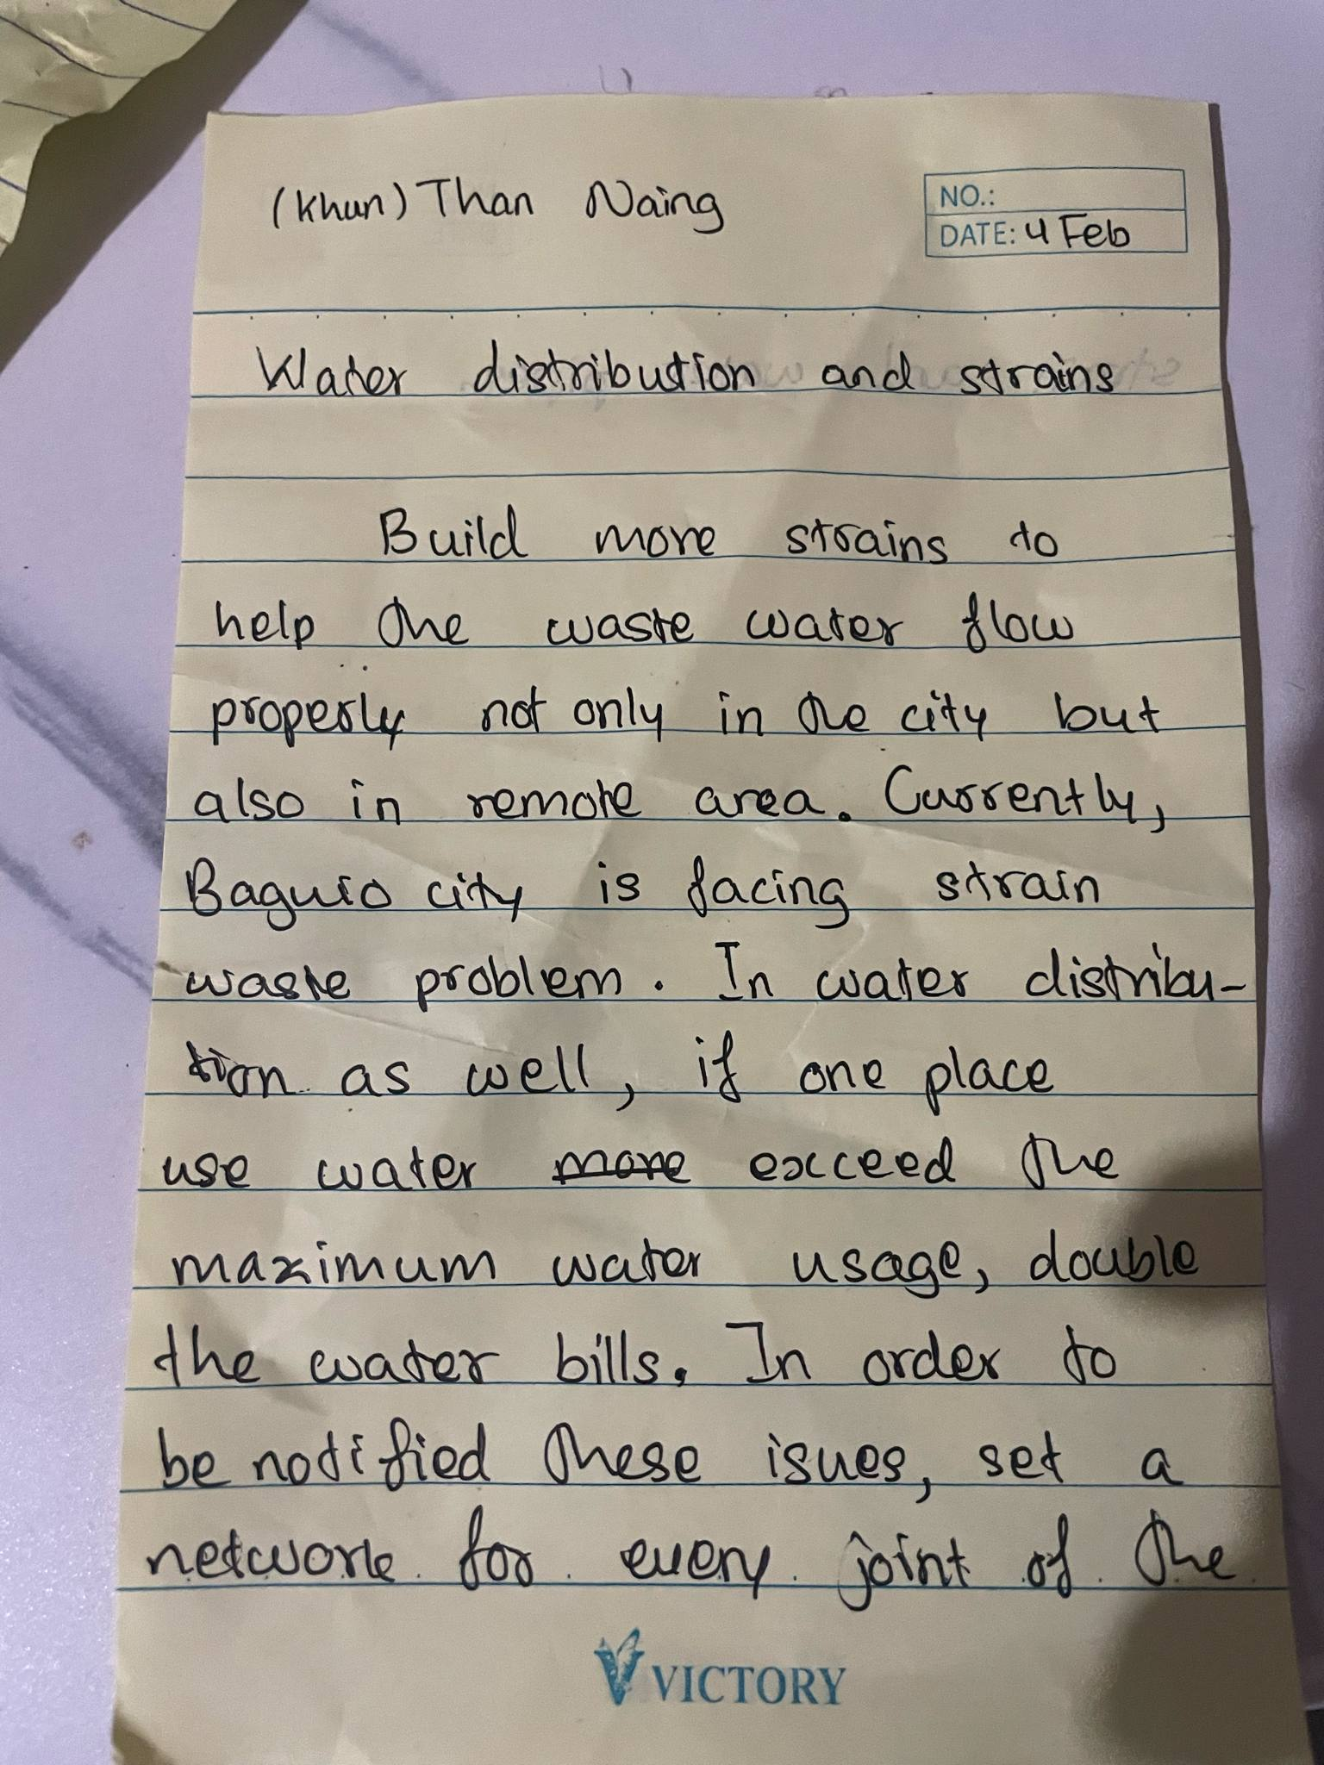

# Quiz 8:

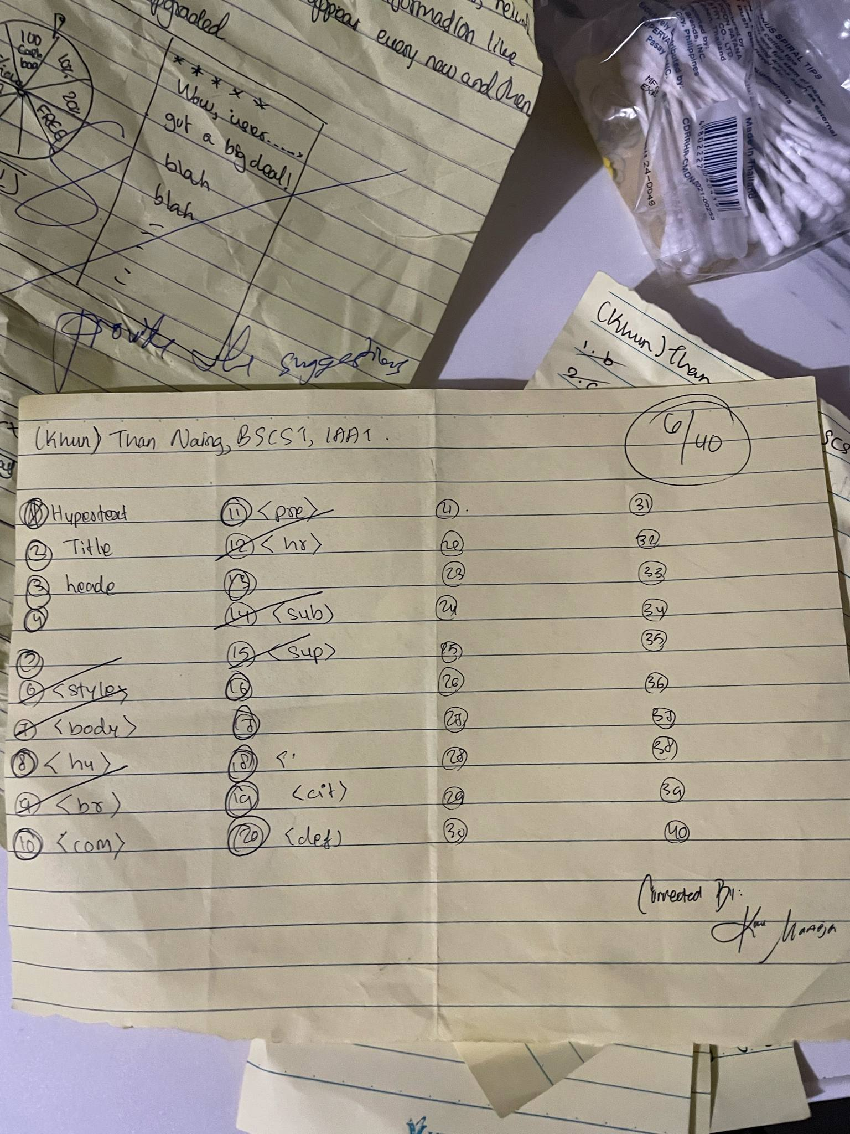

# Quiz 9:

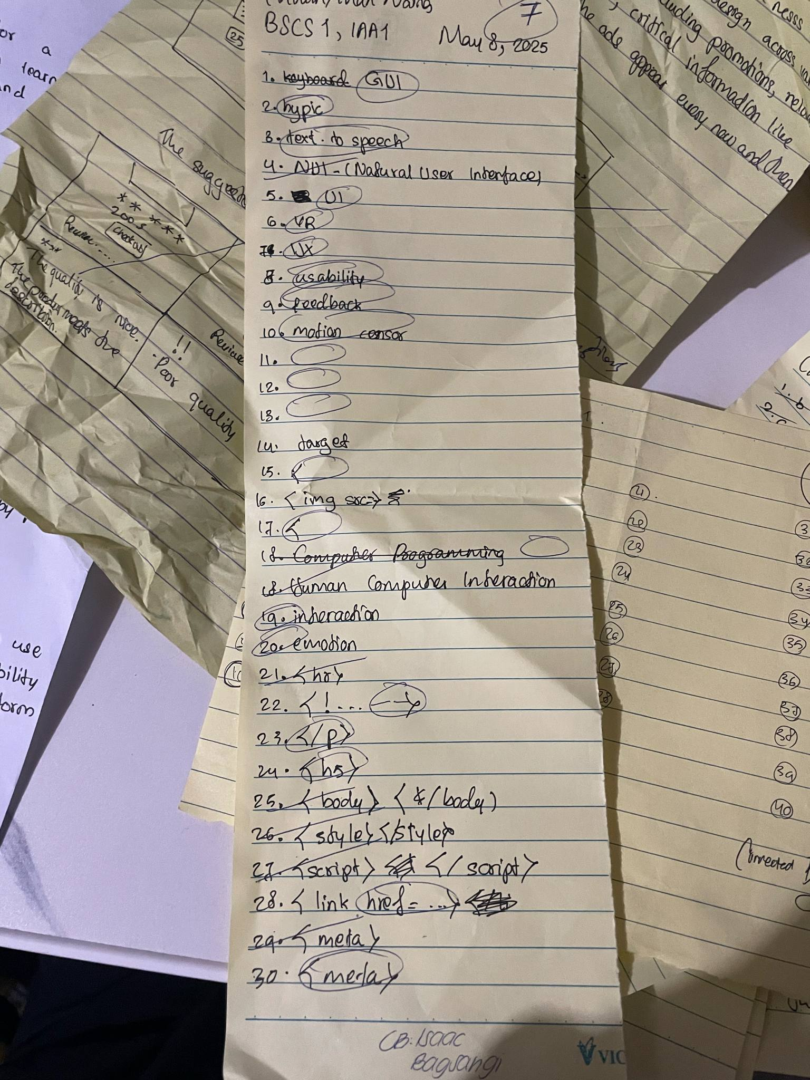

# Quiz 10:

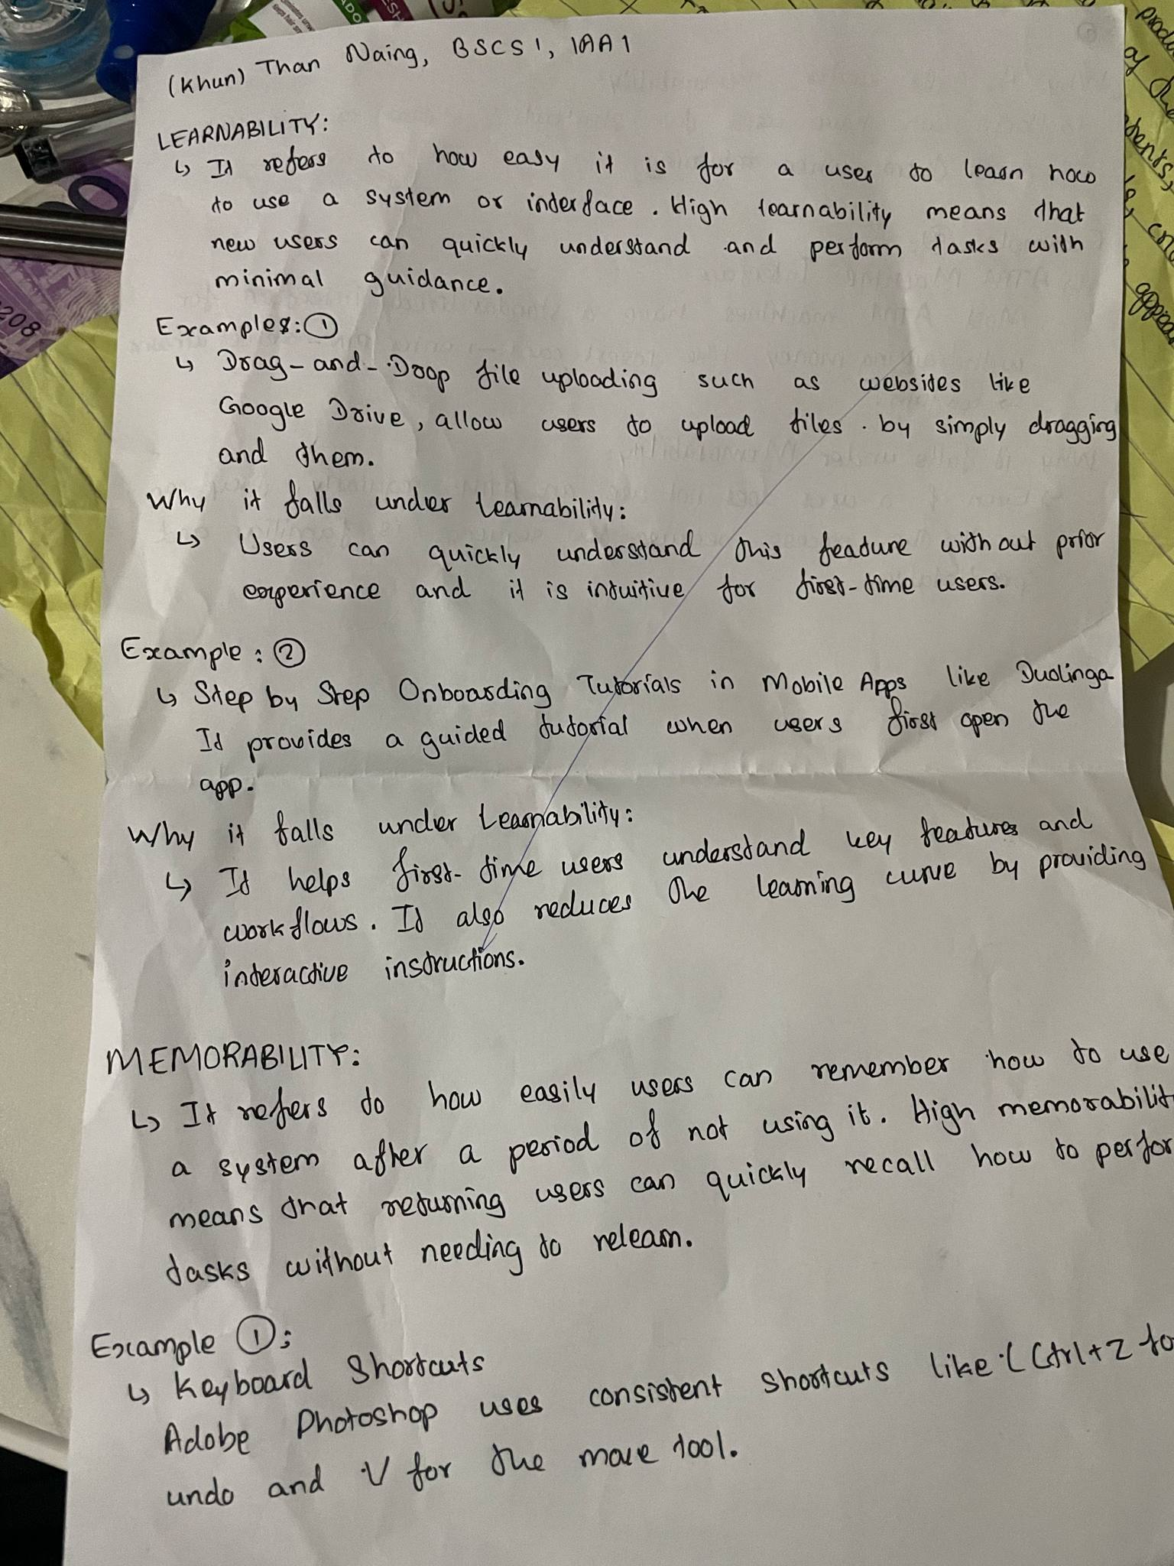

# Quiz 11:

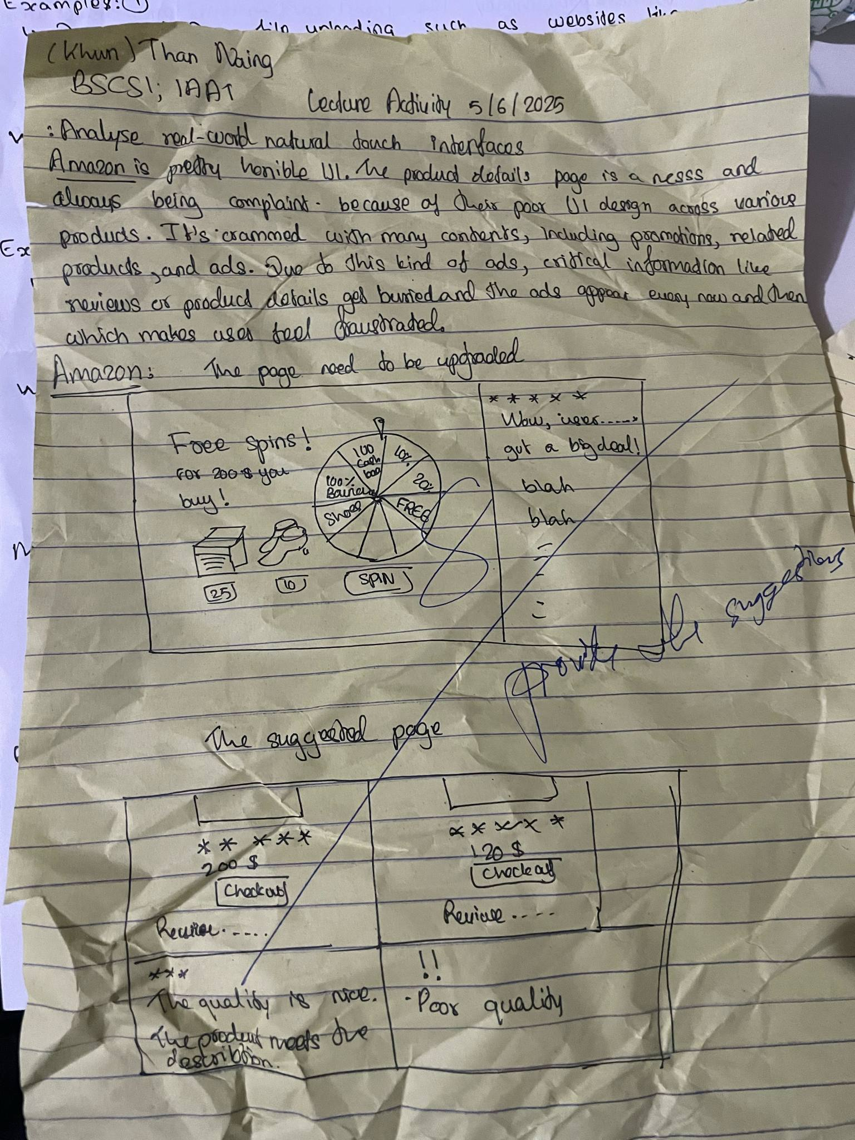

## Seatworks

1. Description: Creating an interface for date picking to arrange events.
2. Reflection: It was a group project and we had to explain how we organized it to the class.

## Assignments

1. Description: Group project: to create a useful website with various accessibility.
2. Reflection: Our group created an artificial website interface for Duolingo with various accessibility to access the application like voice command, typing, goal and next step by representing a hen.

# Experience

## What I like about the course:

What I liked most about HUMCOM 1 was the balance between creativity and technical learning. I enjoyed learning how to code using HTML, CSS, and JavaScript, as it gave me a sense of accomplishment to see my ideas come to life in a web browser. I also appreciated the use of Canva in our projects, as it helped me improve my design skills and understand how to make websites visually appealing. The hands-on activities made the lessons more engaging, and the freedom to explore different design styles allowed me to express my creativity while learning practical skills.

## My Favorite Topics

My favorite topics are the first grading assignment for websites and the midterm group project.

## My Favorite Activities

My favorite activities in HUMCOM 1 included designing website layouts using Canva, which allowed me to express my creativity and understand the basics of visual design. I also enjoyed coding with HTML and CSS, as it was exciting to build and style web pages from the ground up. Lastly, I found the final project presentation both challenging and rewarding because it gave me the opportunity to apply everything I learned and confidently showcase my skills in front of others.

## What can be improved in this subject

One area that can be improved in HUMCOM 1 is providing more guided tutorials or step-by-step demonstrations, especially for beginners who may find coding with HTML, CSS, and JavaScript challenging at first. It would also be helpful to have more hands-on coding exercises during class time to reinforce learning and boost confidence. Lastly, incorporating real-world examples or mini-projects could make the lessons more engaging and relevant to how web design is used in professional settings.

## Most Challenging Topics

The most challenging topics for me in HUMCOM 1 were learning JavaScript and understanding how it works together with HTML and CSS. Unlike HTML and CSS, which focus on structure and design, JavaScript involves logic and programming concepts that took more time to grasp. It was also challenging to debug errors in my code, especially when I couldn’t immediately figure out what went wrong. However, with practice and guidance, I gradually became more comfortable with it.